**SOFTWARE REQUIREMENTS SPECIFICATION**

**For**

**JOB PORTAL**

**Prepared by:-**

*Muthuvel.A , Prakash Kumar.M, Shrinaya.S.K*

**1. Introduction**

**1.1 Purpose**

A job portal is an online platform that connects employers and job seekers by allowing them to post and apply for various job opportunities. A job portal application is a software system that implements the functionalities of a job portal, such as creating user profiles, browsing and searching for jobs, uploading resumes, sending applications, and receiving notifications. The main objective of this document is to illustrate the requirements of the project Job Portal Application using JavaFX. The document gives the detailed description of both functional and non-functional requirements proposed by the client.

**1.2 Scope of Development Project**

The scope of this project is to develop a user-friendly and interactive job portal application using JavaFX, a software platform for creating and delivering desktop applications. JavaFX provides a rich set of graphics and media APIs, as well as a declarative scripting language called FXML, which allows developers to design user interfaces with less code.

**1.3 Definitions, Acronyms, and Abbreviations**

* JavaFX: Java user interface toolkit
* SQL: Structured Query Language
* ER: Entity Relationship
* UML: Unified Modelling Language
* IDE: Integrated Development Environment
* SRS: Software Requirement Specification

**2. Overall Descriptions**

**2.1 Product Perspective**

The Job Portal System will provide a platform for job seekers and employers. The system will include features such as job posting, resume submission, and application tracking. The users will interact with the system through a JavaFX-based graphical user interface.

**2.2 User Classes and Characteristics**

Users will fall into two categories: job seekers and employers.

The Features that are available to Job seekers are :-

* Can search for jobs
* Can apply for jobs by submitting resume
* Track the job application

The Features that are available to Employers are :-

* Post the job vacancy
* Review the resume submitted by applicant
* Manage applications

**2.3 Product Function**

The system will facilitate job seekers in searching and applying for jobs, while employers can post job opportunities and track applications. The database will store user information, job postings, and application data.

ENTITY RELATIONSHIP DIAGRAM OF JOB PORTAL SYSTEM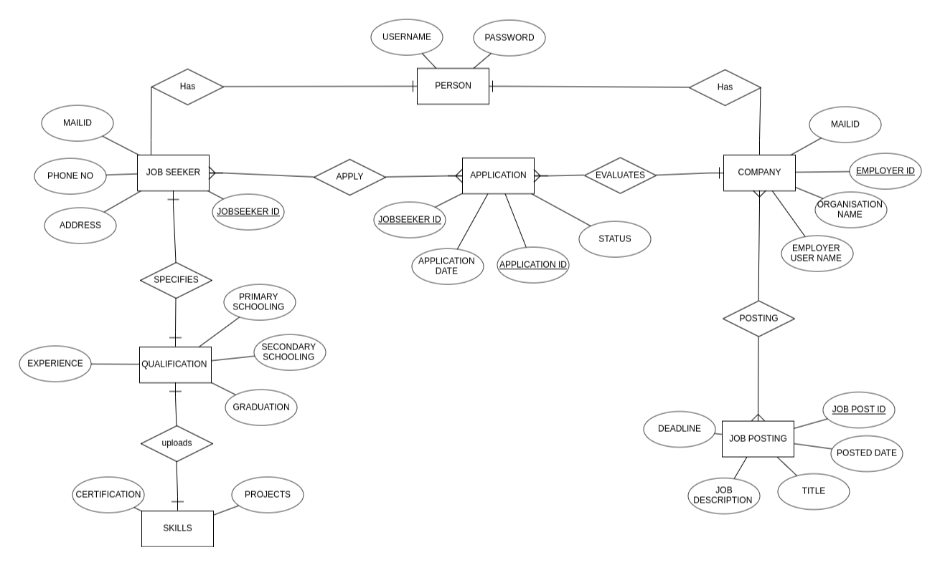

**2.4 Operating Environment**

The Job Portal Application is a desktop application and shall run on any operating system that supports Java, such as Windows, Linux, and Mac OS. The application will use JavaFX as the graphical user interface toolkit, which provides a consistent look and feel across different platforms.

**2.5 Assumptions and Dependencies**

The assumptions are:-

* The coding should be error free and follow the coding standards and conventions of Java and JavaFX.
* The application should be user-friendly and intuitive so that it is easy to use for the users.
* The information of all users, jobs, and employers must be stored in a database that is accessible by the application.
* The application should have enough storage capacity and provide fast access to the database.
* The application should provide search facility and support various filters and criteria.
* The Job Portal Application is running 24 hours a day and can handle multiple users simultaneously.
* Users may access the application from any computer that has Java Runtime Environment installed and an internet connection.
* Users must have their correct usernames and passwords to log in to their accounts and perform actions.

The dependencies are:-

* The specific hardware and software requirements that the application will run on.
* The availability and reliability of the remote database server and the internet connection.
* The end users (employers and job seekers) should have proper understanding of the application and its features.
* The application should have the necessary permissions and security measures to access and manipulate the database.
* The information of all the users must be stored in a database that is consistent and up-to-date.
* Any update regarding the jobs or applications should be reflected in the application and notified to the users.

**2.6 Requirement**

Software Configuration:-

This software package is developed using JavaFX as the front end which is supported by Oracle Corporation. Postgresql as the back end to store the database.

Operating System: Windows 10, Linux, Mac OS Language: Java 11 or higher, JavaFX 11 or higher (front end)

Database: Postgresql

Hardware Configuration:-

Processor: Intel Core i3 or higher

Hard Disk: 80GB or more

RAM: 4GB or more

**2.7 Data Requirement**

The inputs consist of the data entered by the users and the output consists of the data displayed by the application. The output also includes the user receiving the details of their profiles, jobs, and applications. In this project, the inputs will be the data entered by the users such as creating an account, updating their profile, uploading their resume, browsing and searching for jobs, applying for jobs, and sending and receiving messages. The output will be visible when the user requests the application to get details of their profile, such as their name, email, phone number, skills, education, experience, etc

**3. External Interface Requirements**

**3.1 GUI**

The system will provide a graphical interface for users and administrators.

It will allow quick report viewing, verification, and search based on different criteria.

The interface should be customizable, simple, and follow a standard template.

Login Interface:

Users can create accounts and log in. Incorrect login attempts trigger error messages.

Search:

Users can search for jobs by entering the job title or keywords.

Categories View:

Displays categories of jobs and allows the administrator to manage categories.

Administrator’s Control Panel:

Allows administrators to manage users, job postings, and application options.

**4. System Features**

* User Authentication and Validation: The User Authentication and Validation feature ensures secure access for members of the Job Portal application using their unique credentials, such as email and password. This feature includes mechanisms to validate member credentials during the login process.
* Member Credentials: Unique identifiers, such as email and password.

In case of invalid credentials, members receive appropriate error messages.

Security measures, such as account lockout, may be implemented for failed login attempts.

**5. Other Non-functional Requirements**

**5.1 Performance Requirement**

* The system should be fast and accurate.
* Handle expected and unexpected errors to prevent information loss.
* Accommodate a large amount of data without faults.

**5.2 Safety Requirement**

* The database may get crashed at any certain time due to virus or operating system failure. Therefore, it is required to take the database backup so that the database is not lost.
* Proper UPS/inverter facility should be there in case of power supply failure.

**5.3 Security Requirement**

* Secured Database:The system will use a secured database.
* Access Constraints: Normal users can only read information but cannot edit or modify anything except their personal and some other information.
* The system will have different types of users, and every user will have access constraints.
* User Authentication:Proper user authentication should be provided.
* Password Security:No one should be able to hack users’ passwords.
* Access Control:There should be separate accounts for admin and members, such that no member can access the database, and only the admin has the rights to update the database.

**5.4 Requirement Attributes**

* Multiple Admins: There may be multiple admins creating the project, and all of them will have the right to make changes to the system, but the members or other users cannot make changes.
* Open Source: The project should be open source.
* Quality and User-Friendliness: The quality of the database should be maintained in such a way that it is very user-friendly to all the users of the database.
* Easy Installation: The user should be able to easily download and install the system.

**5.5 Business Rules**

* Users should follow system rules and regulations.
* Avoid illegal activities.
* Admin and members should adhere to the defined rules.

**5.6 User Requirement**

A business rule is anything that captures and implements business policies and practices. This includes the rules and regulations that the system users should abide by, such as the cost of the project and the discount offers provided. The users should avoid illegal rules and protocols, and neither admin nor member should cross the rules and regulations.

**6.1 Data and Category Requirement**

In the context of the Job Portal application, diverse user roles delineate the access privileges of individuals. These roles encompass Job Seekers, Employers, and Administrators, each with distinct levels of system access. For administrators, extensive rights are granted, allowing them to modify, delete, and append data as needed. Conversely, users falling under categories other than administrators and excluding specific roles, like Managers, have restricted privileges limited to retrieving information from the database. Furthermore, the Job Portal accommodates various job categories, each requiring the presentation of specific data. It is imperative that data associated with these categories adhere to a standardized coding format, ensuring uniformity and expediency in data representation and retrieval processes.

**6.2 Appendix**

A: Admin, Abbreviation, Acronym, Assumptions ; B: Business rules

C: Class, Client, Conventions ; D: Data requirement, Dependencies ; G: GUI

K: Key ; M: Member ; N: Non-functional Requirement

O: Operating environment ; P: Performance, Perspective, Purpose

R: Requirement, Requirement attributes ; S: Safety, Scope, Security, System features;U: User, User class and characteristics, User requirement

**6.3 Glossary**

The following are the list of conventions and acronyms used in this document and the project:

Administrator: A login id representing a user with user administration privileges to the software

User: A general login id assigned to most users

Client: Intended users for the software

SQL: Structured Query Language; used to retrieve information from a database

SQL Server: A server used to store data in an organized format

Layer: Represents a section of the project

User Interface Layer: The section of the assignment referring to what the user interacts with directly

Application Logic Layer: The section of the assignment referring to the Web Server. This is where all computations are completed

Data Storage Layer: The section of the assignment referring to where all data is recorded

Use Case: A broad level diagram of the project showing a basic overview

Class diagram: It is a type of static structure diagram that describes the structure of a system by showing the system’s cases, their attributes, and the relationships between the cases

Interface: Something used to communicate across different mediums

Unique Key: Used to differentiate entries in a database

**6.4 Class Diagram**

A class is an abstract, user-defined description of a type of data. It identifies the attributes of the data and the operations that can be performed on instances (i.e. objects) of the data. A class of data has a name, a set of attributes that describes its characteristics, and a set of operations that can be performed on the objects of that class. The classes’ structure and their relationships to each other frozen in time represent the static model. In this project there are certain main classes which are related to other classes required for their working. There are different kinds of

relationships between the classes as shown in the diagram like normal association, aggregation,and generalization. The relationships are depicted using a role name and multiplicities. Here ‘Jobseeker’, ‘Employer’ and ‘Job Posting ‘ are most important classes which are related to each other

